**Meet Your Instructors**

We have a great group of instructors for each of the courses of the Nanodegree program. For some courses, you'll hear from just one, and others include multiple instructors. Each of them brings expertise from working in the field and experience teaching others. Below is a short bio of each instructor, and you'll learn more about them during the courses they teach.

**Course 1 - Data Modeling**

[[](https://classroom.udacity.com/nanodegrees/nd027/parts/1be1ed3e-c0c5-4b03-be23-7f4393a11fca/modules/20001b0c-9bbd-49c3-b0f2-5d1578fa6e22/lessons/42bc312a-38dd-4953-8695-3735a251b1db/concepts/72cb3d7a-2e28-4343-aa6a-2b0cb6596487)](https://classroom.udacity.com/nanodegrees/nd027/parts/1be1ed3e-c0c5-4b03-be23-7f4393a11fca/modules/20001b0c-9bbd-49c3-b0f2-5d1578fa6e22/lessons/42bc312a-38dd-4953-8695-3735a251b1db/concepts/72cb3d7a-2e28-4343-aa6a-2b0cb6596487)

**Amanda Moran, Developer Advocate at Datastax**

Amanda has six years of experience as a Software Engineer at HP, Esgyn, Lockheed Martin, and Teradata. She's an Apache Committer and on the Project Management Committee for Apache Trafodion. She's currently a Developer Advocate at Datastax. A developer advocate is a software engineer that is the middle layer between the internal engineering organization and external users. Amanda is proficient in four different distributed databases and focuses primarily on Cassandra in her current role. She has an M.S. in Computer Science and Engineering from Santa Clara University and a B.S. in Biology from University of Washington.

**Course 2 - Cloud Data Warehouses**

[[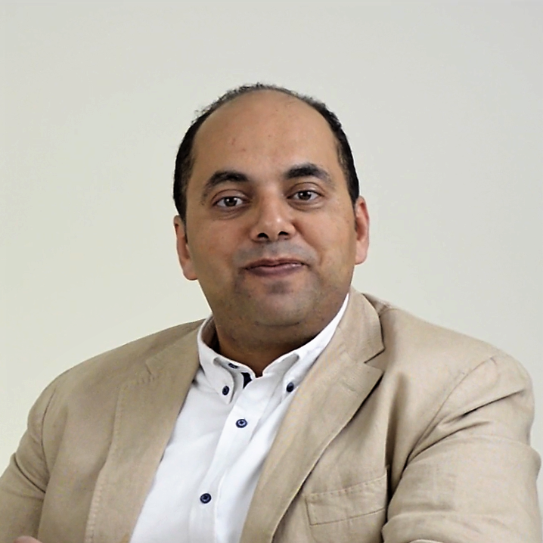](https://classroom.udacity.com/nanodegrees/nd027/parts/1be1ed3e-c0c5-4b03-be23-7f4393a11fca/modules/20001b0c-9bbd-49c3-b0f2-5d1578fa6e22/lessons/42bc312a-38dd-4953-8695-3735a251b1db/concepts/72cb3d7a-2e28-4343-aa6a-2b0cb6596487)](https://classroom.udacity.com/nanodegrees/nd027/parts/1be1ed3e-c0c5-4b03-be23-7f4393a11fca/modules/20001b0c-9bbd-49c3-b0f2-5d1578fa6e22/lessons/42bc312a-38dd-4953-8695-3735a251b1db/concepts/72cb3d7a-2e28-4343-aa6a-2b0cb6596487)

**Sameh El-Ansary, CEO at Novelari and Professor at Nile University**

Sameh is an all around Big Data expert. He's founded three big data focused companies, one of which he's currently the CEO. At Novelari, he consults for companies on big data initiatives and helps shape their data engineering strategies. He's also an assistant professor at Nile University, where he teaches data engineering courses, such as Spark and Kafka. Sameh has a PhD in Computer Science from KTH Royal Institute of Technology.

[[](https://classroom.udacity.com/nanodegrees/nd027/parts/1be1ed3e-c0c5-4b03-be23-7f4393a11fca/modules/20001b0c-9bbd-49c3-b0f2-5d1578fa6e22/lessons/42bc312a-38dd-4953-8695-3735a251b1db/concepts/72cb3d7a-2e28-4343-aa6a-2b0cb6596487)](https://classroom.udacity.com/nanodegrees/nd027/parts/1be1ed3e-c0c5-4b03-be23-7f4393a11fca/modules/20001b0c-9bbd-49c3-b0f2-5d1578fa6e22/lessons/42bc312a-38dd-4953-8695-3735a251b1db/concepts/72cb3d7a-2e28-4343-aa6a-2b0cb6596487)

**Juno Lee, Content Developer at Udacity**

Juno is a content developer at Udacity, where she creates projects and courses and coaches other instructors who partner with Udacity. Prior to Udacity, Juno was a data scientist at Looplist where she built a recommendation engine to personalize online shopping experiences; computer vision and natural language processing models to analyze product data; and tools to generate insight into user behavior. Juno is a graduate from the Galvanize Data Science program.

**Course 3 - Data Lakes with Spark**

[[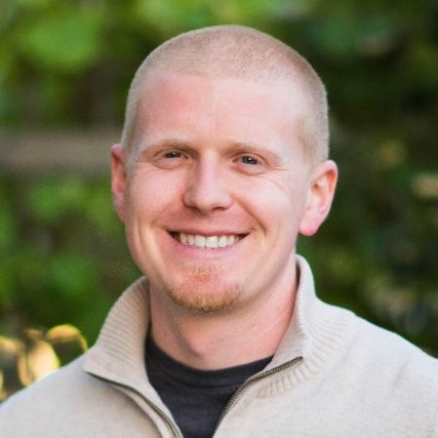](https://classroom.udacity.com/nanodegrees/nd027/parts/1be1ed3e-c0c5-4b03-be23-7f4393a11fca/modules/20001b0c-9bbd-49c3-b0f2-5d1578fa6e22/lessons/42bc312a-38dd-4953-8695-3735a251b1db/concepts/72cb3d7a-2e28-4343-aa6a-2b0cb6596487)](https://classroom.udacity.com/nanodegrees/nd027/parts/1be1ed3e-c0c5-4b03-be23-7f4393a11fca/modules/20001b0c-9bbd-49c3-b0f2-5d1578fa6e22/lessons/42bc312a-38dd-4953-8695-3735a251b1db/concepts/72cb3d7a-2e28-4343-aa6a-2b0cb6596487)

**David Drummond, VP of Engineering at Insight**

David is the VP of Engineering at Insight, which mentors recent M.A. and PhD grads into tech jobs at top companies. He has mentored dozens of students into data engineering jobs at some of the most data-driven companies in the world. At Insight, David helped develop the core curriculum for the Data Engineering program and led Insight's expansion from Silicon Valley to New York City. He joined Insight as a fellow and has progressed into his current role. David has a PhD in Theoretical and Mathematical Physics from University of California, Riverside.

[[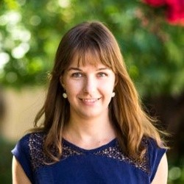](https://classroom.udacity.com/nanodegrees/nd027/parts/1be1ed3e-c0c5-4b03-be23-7f4393a11fca/modules/20001b0c-9bbd-49c3-b0f2-5d1578fa6e22/lessons/42bc312a-38dd-4953-8695-3735a251b1db/concepts/72cb3d7a-2e28-4343-aa6a-2b0cb6596487)](https://classroom.udacity.com/nanodegrees/nd027/parts/1be1ed3e-c0c5-4b03-be23-7f4393a11fca/modules/20001b0c-9bbd-49c3-b0f2-5d1578fa6e22/lessons/42bc312a-38dd-4953-8695-3735a251b1db/concepts/72cb3d7a-2e28-4343-aa6a-2b0cb6596487)

**Judit Lantos, Data Infrastructure Engineering at Split**

Judit is a data infrastructure engineer at Split where she work's extensively with Spark to handle big data tasks. Prior to Split, she led the Data Engineering team at Insight’s Silicon Valley office. She also has extensive experience in medical imaging research at Stanford and Mediso Medical Imaging Systems. Judit earned her M.A. in Engineering Physics from Budapest University of Technology and Economics.

You'll also hear again from Sameh during this course.

**Course 4 - Data Pipelines**

[[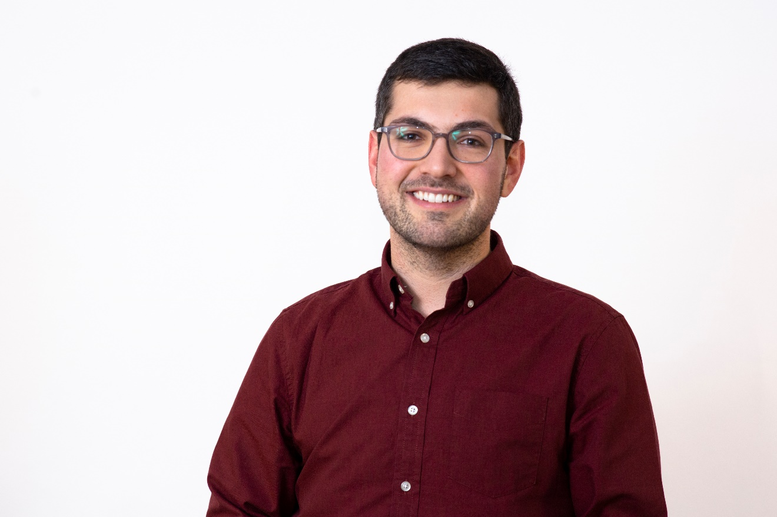](https://classroom.udacity.com/nanodegrees/nd027/parts/1be1ed3e-c0c5-4b03-be23-7f4393a11fca/modules/20001b0c-9bbd-49c3-b0f2-5d1578fa6e22/lessons/42bc312a-38dd-4953-8695-3735a251b1db/concepts/72cb3d7a-2e28-4343-aa6a-2b0cb6596487)](https://classroom.udacity.com/nanodegrees/nd027/parts/1be1ed3e-c0c5-4b03-be23-7f4393a11fca/modules/20001b0c-9bbd-49c3-b0f2-5d1578fa6e22/lessons/42bc312a-38dd-4953-8695-3735a251b1db/concepts/72cb3d7a-2e28-4343-aa6a-2b0cb6596487)

**Ben Goldberg, Staff Engineer at SpotHero**

Ben spent the beginning of his career working on computer vision, teaching airborne systems to understand and parse the world around them. He also worked at an artificial intelligence startup transforming raw data sets into written language. He is currently a Staff Engineer at SpotHero. At SpotHero he founded, built, and led the Data Engineering team. He's also a contributor to Apache Airflow and one of the three original contributors to the Airflow Kubernetes Executor. Ben has a B.S. in computer science from University of Wisconsin.